**Factors Associated With Variation in Single-Dose Albendazole Pharmacokinetics: A Systematic Review and Modelling Analysis**

Charles Whittaker1**,** Cédric B. Chesnais2, Sébastien D.S. Pion2, Joseph Kamgno3, Martin Walker4, Maria-Gloria Basáñez1* & Michel Boussinesq2*

1Department of Infectious Disease Epidemiology, Imperial College London, London, UK

2Institut de Recherche pour le Développement (IRD), Montpellier, France

3Centre for Research on Filariasis & other Tropical Diseases, and Faculty of Médicine and Biomedical Sciences, University of Yaoundé I., Yaoundé, Cameroon

4Department of Pathobiology and Population Sciences, Royal Veterinary College, Hatfield, UK

* Indicates joint co-authorship

**Keywords:** Albendazole, pharmacokinetics, treatment, parasitic infections, helminthiases

**Key Points:** A systematic review and pharmacokinetic modelling approach was undertaken to explore factors associated with variation in albendazole pharmacokinetics following receipt of a single oral dose. Receipt of a fatty meal, age and parasitic infection were all significantly associated with variation in the drug’s pharmacokinetic profile.

**Abstract:**

Albendazole is a widely used anti-parasitic medication characterised by significant inter-individual pharmacokinetic variation. This variation is thought to have important consequences for treatment success, but our understanding of the factors associated with this variation remains far from complete. Motivated by this, we carried out a systematic review was carried out to identify references containing temporally disaggregated data on the blood concentration of albendazole and/or albendazole sulfoxide following a single oral dose. These data were then integrated into a modelling framework in order to infer key pharmacokinetic parameters and relate them to characteristics of the populations being treated: age, weight, sex, dosage, infection status, and whether patients had received a fatty meal prior to treatment or other drugs alongside albendazole.We identify a number of factors systematically associated with albendazole pharmacokinetic variation. These factors impact different aspects of the pharmacokinetic profile: whilst age is significantly associated with albendazole sulfoxide half-life, receipt of a fatty meal prior to treatment was associated with increased albendazole bioavailability (and by extension, CMax and AUC). Parasitic infection (particularly echinococcosis and neurocysticercosis) was associated with altered pharmacokinetic parameters, with infected populations displaying distinct characteristics to healthy ones. These results provide insight into some of the factors associated with variation in albendazole’s pharmacokinetics and suggest potential avenues for programmatic optimisation of the drug’s delivery.

**Introduction**

Albendazole is a broad-spectrum medication used widely in the treatment of a variety of parasitic worm infections. This includes usage in a clinical context, where multiple-dose regimen are used to treat infections with the larval stages of *Taenia solium* ((neuro-)cysticercosis)1 or of *Echinococcus* sp. (principally cystic and alveolar echinococcosis due to *E. granulosus* and *E. multilocularis*, respectively)2. It has also been used extensively in programmatic contexts, where a single dose has been delivered to communities as part of mass treatment against soil-transmitted helminthiases3 (STHs, due to *Ascaris lumbricoides*, *Trichuris* *trichiura*, *Necator americanus* and *Ancylostoma duodenale*); lymphatic filariasis4 (delivered alone or alongside ivermectin and/or diethylcarbamazine5) and in individuals with loiasis whose *Loa loa* microfilarial densities are high enough to preclude safe treatment with microfilaricidal anthelmintics (such as diethylcarbamazine or ivermectin)6.

Whilst the therapeutic efficacy of albendazole has been established for a wide array of helminthic parasites, the drug’s pharmacokinetics (and those of its pharmacologically active metabolite, albendazole sulfoxide) are characterised by extensive inter- and intra-individual variation. This variation has been consistently observed across a wide range of studies (see Jung Cook et al 20127 for a review and its implications for treatment), and is typically attributed to the drug’s limited solubility in the gastrointestinal tract and extensive first-pass metabolism by the liver (responsible for rapid conversion of albendazole to albendazole sulfoxide). This variation is thought to contribute to the failure of cure in some treated patients – whilst some require only one course of treatment, others require multiple rounds and in a limited number of instances, failure of treatment has been observed8–10. This variation in outcomes observed in clinical settings has also been seen in field studies, where highly variable cure rates STHs have been observed depending on the setting11 – for example, infection with hookworm treated using the drug varied from 53% to 95% across different communities in Ghana12.

A number of factors are thought to underlie this variation in pharmacokinetic dynamics – several studies have examined the influence of different drivers, including sex13, co-administered drugs14,15, delivery of albendazole alongside a fatty meal16,17 and infection status18 on the pharmacokinetic profile of albendazole and/or albendazole sulfoxide. These studies typically only analyse a single factor however, and so a systematic understanding of the comparative impact of different factors on albendazole’s pharmacokinetics remains outstanding. Given albendazole’s widespread usage in programmatic contexts characterised by infrequent delivery (typically annually or biannually) of a single dose, insight into mechanisms by which to improve the pharmacokinetic profile of albendazole delivered in this context could have significant public health relevance.

Motivated by this, we conducted a systematic review of the literature to identify references containing temporally disaggregated information on albendazole and/or albendazole sulfoxide concentrations in the blood following treatment with a single oral dose. To this data, we fit a model of albendazole and albendazole sulfoxide’s dynamics that captures key phenomena associated with the drug’s metabolism, including extensive first-pass metabolism19 and its established low bioavailability20. We fit this model to data collated as part of the systematic review to infer key pharmacokinetic parameters, including albendazole bioavailability, albendazole sulfoxide half-life, AUC and CMax. We then relate these parameter estimates to characteristics of the patient populations being treated and the treatment regimen received.

**Methods**

**Systematic Review of Albendazole Pharmacokinetic Literature**

Web of Science and PubMed databases were searched on 4th July 2019 using the keywords “albendazole” AND (treatment* OR dose* OR pharma* OR “half-life” OR “half life”) in order to identify references containing temporally disaggregated data detailing the concentration of albendazole and/or albendazole sulfoxide in the blood following treatment with a single dose of the drug. A total of 5690 unique records were identified through this search process, with 206 records retained for full text evaluation following Title and Abstract screening **(Fig 1)**. Studies lacking the required information on blood concentration levels over time, or that had been carried out *in vitro* or in non-human subjects were subsequently excluded. Following this, a total of 32 references were included, yielding 92 time series describing the evolution of blood concentrations of albendazole and/or albendazole sulfoxide following treatment with a single dose. For each time series, we extracted the data describing evolution of albendazole/albendazole sulfoxide levels over time, as well as an array of metadata. These include characteristics of the treatment regimen (dose, fasting state, co-administered drugs), as well as the patients receiving treatment (sex, age, infection status and weight). In the majority of instances, presented data were reported for a population of patients rather than individuals. In these instances, population averages for factors such as age, weight etc were extracted. A full list of these references, as well as further information about each study and how the data was extracted is available in ***Supplementary Information: Data Extraction, Collation and Initial Processing***.

**Mathematical Model Construction and Fitting**

We developed a model describing the evolution of albendazole and albendazole sulfoxide concentrations in the blood following receipt of a single dose, based on series of linked ordinary differential equations (ODEs) of albendazole and its metabolite albendazole sulfoxide **(Fig 2)**. It incorporates a number of pharmacokinetic phenomena relevant to albendazole, including its well-established, limited bioavailability (thought to be a product of its poor solubility along the gastrointestinal tract21) and the extensive first-pass metabolism of albendazole to albendazole sulfoxide known to occur in the liver22. This model was fitted individually to each of the 92 collated time-series within a Bayesian framework, utilising an adaptive Metropolis-Hastings based Markov Chain Monte Carlo (MCMC) sampling scheme for parameter inference. Uninformative priors were used for each of the parameters being inferred. For each dataset, a total of 25,000 iterations were run, with the first 5,000 discarded as burn in, and leaving 20,000 iterations available for parameter inference. Further information on the exact formulation of the model and the fitting process is available in ***Supplementary Information: Model Construction, Fitting and Inference***.

**Regression Linking Pharmacokinetic Properties to Patient Characteristics**

From the 92 fitted time-series, we extracted estimates of key pharmacokinetic parameters and regressed them onto the collected metadata (describing aspects of the patient population and treatment regimen received) to assess the influence of various factors on variation in albendazole and albendazole sulfoxide’s pharmacokinetics. There pharmacokinetic parameters were $k_{AlbSO}$ (the half-life of albendazole sulfoxide), the bioavailability of albendazole (the proportion of administered albendazole absorbed from the gut into the blood), $C_{Max}$ (the peak concentration of the drug in the blood) and $AUC$ (reflecting the total exposure to the drug after administration of the dose, calculated over a time-period of 50 hours). $k_{AlbSO}$ and $bioavailability$ are model parameters directly estimated during the fitting process described above (see **Fig 2** for where they feature in the model structure), and so for each time-series, the median parameter estimate from each time-series was used in the regression. For $C_{Max}$ and $AUC$, in order to control for differences in dosages between studies (which would directly impact estimates of these two quantities), we used the fitted model (and parameter estimates) for each time series to generate a hypothetical pharmacokinetic curve assuming a standardised dose of 400mg – we then calculated $C_{Max}$ and $AUC$ from this hypothetical pharmacokinetic curve to give estimates of the two parameters standardised by the dose received – we subsequently refer to these quantities as $C_{Max400}$ and ${AUC}_{400}.$

**Results**

**Systematic Review Results and Study Characteristics**

A total of 32 references containing 92 time-series detailing the concentration of albendazole and/or albendazole sulfoxide in the blood following treatment with a single dose of albendazole were identified. 44 time-series were data for a single individual and 58 time-series described average concentrations through time for a group of individuals (mean group size = 12.2, interquartile range = 6-14), with the data comprising a total number of 629 individuals who had received a single dose of albendazole. Of the 92 time-series identified, information on the sex of participants was available for 67 time-series (37 from male participants, 24 including a mixture of males and females, and 6 from female participants), with information on mean age and weight available for 79 and 69 time series respectively. 16 time-series were from children under the age of 16. Information on whether treatment was taken with a fatty meal was available for 75 time series (29 received a fatty meal, the remainder did not), whilst infection status was available for 91 time series (48 were from healthy patient populations, 16 where individuals had neurocysticercosis, 14 with echinococcosis, 7 with onchocerciasis, 3 with lymphatic filariasis, 2 with giardiasis and 1 with hookworm). The median dose received was 400mg (range 200mg – 2205mg); co-administered drugs included ivermectin (n=7), diethylcarbamazine (DEC, n = 7), praziquantel (n=4), ritonavir (n=2), dexamethasone (n=2), amoxicillin (n=1), gentamycin (n=1), metronidazole (n=1), ceftriaxone (n=1), levamisole (n=1) and oxantel pamoate (n=1). See **Supp** **Table 1** for full details of each included study and time-series.

**Pharmacokinetic Modelling of Albendazole and Albendazole Sulfoxide Dynamics**

To each of these collated time series, we fitted a model describing the dynamics of albendazole and albendazole sulfoxide concentrations in the blood following receipt of a single oral dose (see **Fig 2** for model structure and formulation). This model was fitted individually to each time series within a Bayesian MCMC-based framework (see **Supp Fig X** for individual model fitting results for each time-series). Our results highlighted significant variation in model estimates of key pharmacokinetic parameters including $k_{AlbSO}$ (the half-life of albendazole sulfoxide), the bioavailability of albendazole (i.e. proportion of administered albendazole absorbed from the gut into the blood), $C_{Max400}$ (peak modelled concentration of albendazole sulfoxide in the blood following receipt of a hypothetical 400mg dose) and ${AUC}_{400}$ (total modelled exposure to albendazole sulfoxide following receipt of a hypothetical 400mg dose). Stratifying the modelled pharmacokinetic profiles by various characteristics of the patient population suggested possible systematic pharmacokinetic differences associated with patient and treatment regimen related factors, although also extensive between-study variation in dynamics **(Fig 3)**.

In order to explore these relationships more formally, we carried out a multivariate regression analysis to assess which of the factors in **Fig 3** were statistically associated with differences in these pharmacokinetic parameters. Receipt of a fatty meal prior to treatment increased the bioavailability of albendazole by 38% on average (p<0.01) and resulted in a significantly higher peak blood concentration ($C_{Max400}$ being 353mg/ml higher or almost 2x higher in individuals receiving a fatty meal on average, p<0.01). Receiving a fatty meal prior to treatment was also associated with a 1.53x higher overall ${AUC}_{400}$ than in fasted individuals (p<0.01). Higher doses were associated with reduced albendazole bioavailability (with bioavailablity reducing approximately 1% for each 100mg increase in dosage, p=0.03). We did not observe any significant differences in pharmacokinetic parameters between males/all-male groups compared to all-female groups or mixed sex groups.

Parasitic infection was associated with significant differences in pharmacokinetic parameters compared to healthy individuals. Whilst we did not detect any significant differences when considering infection status as a binary indicator (i.e. whether an individual had a parasitic infection or not), stratifying the infected population further by specific disease revealed significant associations between particular diseases. There was a significant association between neurocysticercosis infection and albendazole sulfoxide half life (median 12 hours compared to 10.5 hours in healthy individuals, p=0.047); and significant effects of echinococcosis infection on bioavailability (+14% compared to health individuals, p<0.01) and $C_{Max400}$ and ${AUC}_{400}$ (with both increased by almost 4-fold, p<0.01 in both instances).

As a sensitivity analysis, we repeated the analyses described above controlling for the dose of albendazole received per kilogram of body weight (available only for a subset of the time-series due to a lack of complete information about participant weight), rather than the raw amount (in mg, not standardised by body weight) given to an individual. All significant associations described above were retained when conducting this subset sensitivity analysis (see **Supp Table X**). Additionally however, we observed a difference between age-groups in the modelled estimates of $k_{AlbSO}$, with the median half-life of albendazole sulfoxide 12.4 hours in adults compared to only 8.04 hours in children under the age of 16 (p<0.01).

We did not observe any significant association between onchocerciasis infection and the considered pharmacokinetic parameters. We did not detect a significant effect of co-administered drugs on albendazole’s pharmacokinetics, though it is important to note the heterogeneous array of drugs co-administered across the collated dataset and comparative paucity of time-series featuring each of the drugs precluded a stratified analysis of each drug individually (as was possible with disease status). This necessitated combining them into the binary category or yes/no co-administration. The corollary of this is that these analyses are not powered to reliably detect drug-drug interactions with albendazole (which are well documented in the literature).

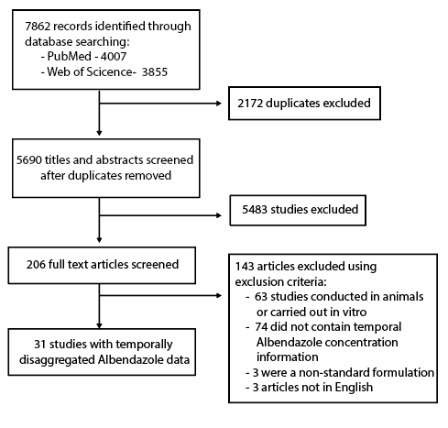

**Figure 1: PRISMA diagram illustrating the systematic review workflow.** Web of Science and PubMed were searched on 4th July 2019 using the keywords albendazole AND (treatment* OR dose* OR pharma* OR “half-life” OR “half life”). This produced a total of 5690 results after duplicate removal, of which 206 were retained for full text screening. 143 of the retained articles were subsequently excluded based on pre-defined exclusion criteria, yielding 31 studies containing temporally disaggregated data on albendazole blood concentrations following treatment with a single dose; these 31 references contained 52 time series measuring albendazole blood concentrations over time in different populations in total.

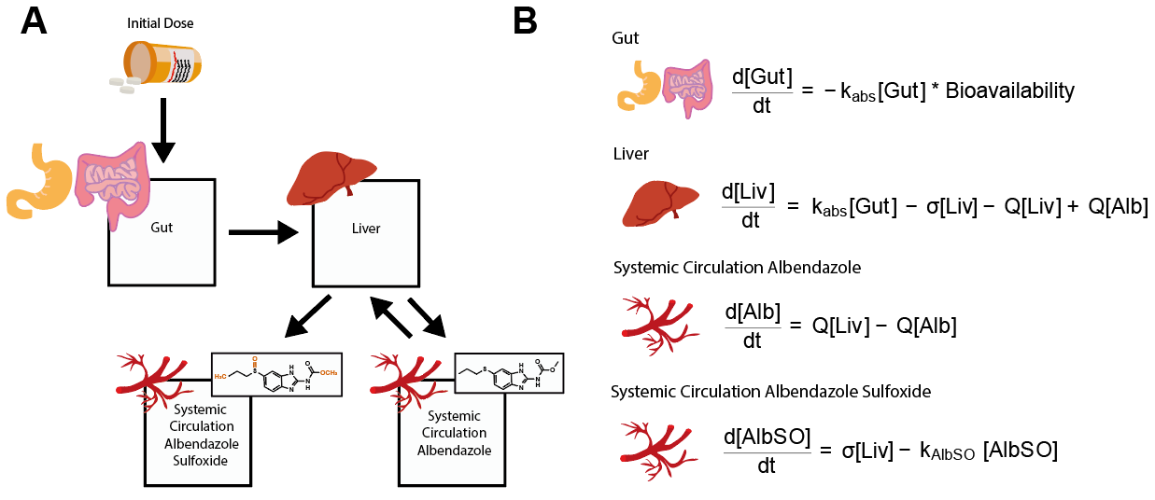

**Figure 2: Schematic of the model describing albendazole and albendazole sulfoxide dynamics and pharmacokinetics.** A compartmental model consisting of a series of linked ordinary differential equations (ODEs) was developed to simulate the pharmacokinetics of albendazole and its pharmacodynamically active metabolite, albendazole sulfoxide, in the blood following a single oral dose. **(A)** Model schematic, illustrating the model structure and the way in which the different compartments are linked. **(B)** The ordinary differential equations governing the pharmacokinetic model, representing the concentration of albendazole in the gut, the liver and systemic circulation, as well as the concentration of albendazole sulfoxide in systemic circulation.

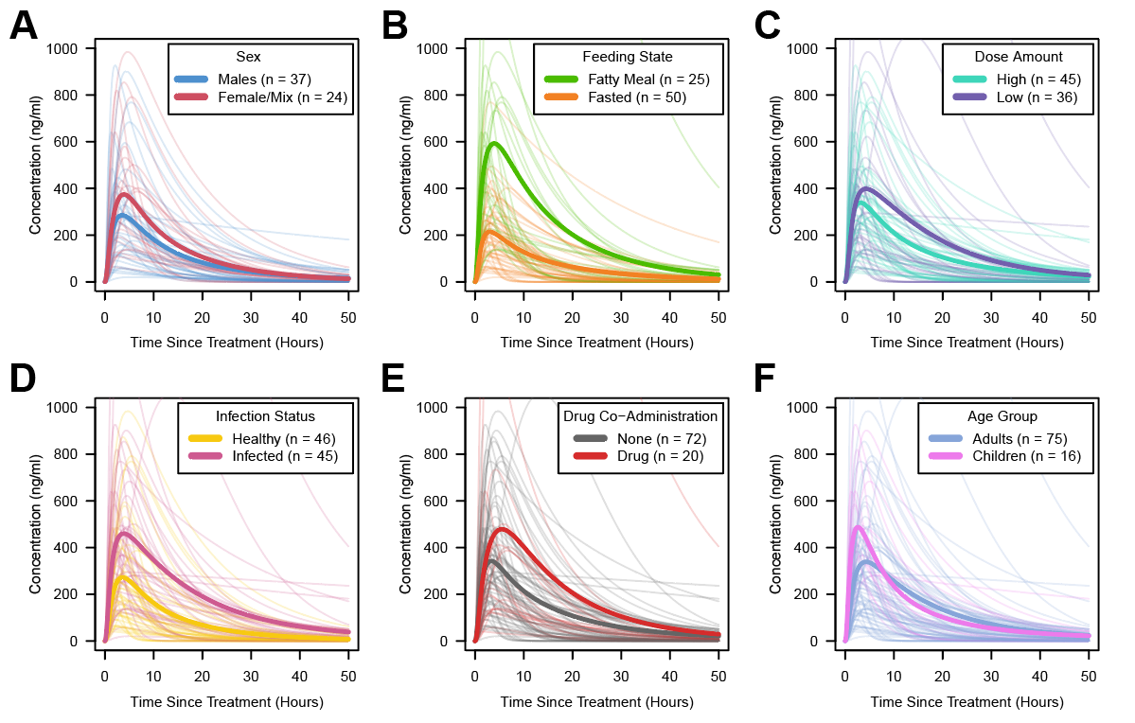

**Figure 3: Albendazole sulfoxide pharmaconkinetic variability, stratified by patient and dosage features.** In all panels displayed above, each pale line represents the fitted model output for a single time series, with the darker lines representing the average of the time series for a given category. Factors explored were **(A)** Sex; **(B)** Feeding Status (according to whether groups had received the single dose of albendazole whether the dose was taken alongside a fatty meal or not); **(C)** Dose (with time-series crudely categorised into high/low strata based on whether the dose was higher than 400mg); **(D)** Infection Status (defined based on whether the patient population represented healthy individuals or those infected with parasitic infections necessitating treatment); **(E)** Co-Administered Drugs (i.e. whether albendazole was delivered alone or in tandem with other drugs); and **(F)** Age Group (defined based on whether the average age of the patients was below or above 16 years).

**Table 1: Regression Outputs Relating Pharmacokinetic Properties to Characteristics.** Inferred parameters from the fitted pharmacokinetic curves, specifically albendazole bioavailability, albendazole sulfoxide half-life, CMax and AUC were regressed onto various patient population demographic and treatment metadata. The results of this multivariate regression are displayed below.

|  |  |  |  |  |
| --- | --- | --- | --- | --- |
|  | **Bioavailability** | **AlbSO Half-Life** | **AUC (For Standardised 400mg Dose)** | **CMax (For Standardised 400mg Dose)** |
| **Sex**  **(Male = Ref)** | p=0.25 | p=0.90 | p=0.44 | p=0.15 |
| **Fatty Meal** | p=0.001  (+14%) | p=0.93 | p=0.01  (+6141) | p<0.001  (+330) |
| **Age Group**  **(Adults = Ref)** | p=0.67 | p=0.19 | p=0.12 | p=0.95 |
| **Dose (Mg)** | p=0.03  (-1.1% per 100mg increase) | p=0.19 | p=0.30 | p=0.10 |
| **Parasitic Infection**  **(Ref = None)** | p=0.41 | p=0.10 | p=0.46 | p=0.95 |
| **🡺 Onchocerciasis** | p=0.09 | p=0.48 | p=0.51 | p=0.08 |
| **🡺 Echinococosis** | p=0.04  (+14%) | p=0.15 | p<0.001  (+15604) | p<0.001  (+538) |
| **🡺 Neurocysticercosis** | p=0.74 | p=0.047  (-1.5 hours) | p=0.32 | p=0.14 |
| **Co-Administered Drugs**  **(Ref = None)** | p=0.09 | p=0.48 | p=0.58 | p=0.27 |

**Discussion**

Despite widespread usage, significant uncertainty surrounds the factors underlying variation in the pharmacokinetics of the drug albendazole. Whilst other studies have previously examined these factors individually (e.g.17,23–25 amongst others), a systematic, multivariate analysis of different factors together remained outstanding. Integrating the results of a systematic review of the literature with a mathematical model of albendazole/albendazole sulfoxide dynamics, our work highlights the impact a number of different factors play in shaping the pharmacokinetic profile of the drug (and its metabolite) in the blood following receipt of a single oral dose. Importantly, our results suggest that these different factors influence different pharmacokinetic parameters, and hence alter different aspects of the pharmacokinetic profile of the drug in the blood.

In-keeping with previous work16,17,26–28, consumption of a fatty meal prior to receiving the dose was associated with increases in the bioavailablity of albendazole, increasing the amount absorbed into the body (and concomitantly elevating the AUC and CMax­ values achieved), a phenomenon thought to be attributed to changes in the drug’s solubility (previously shown to be the rate-limiting step in albendazole’s bioavailablity and absorption21) when delivered alongside a fatty meal28. Whilst prior results from the literature have suggested limited differences between men and women in albendazole’s pharmacokinetics (specifically with regards to the AUC and CMax13), we did not observe any significant differences here. However, important caveats to our results are that the lack of individual data in many cases precluded examination of men and women separately – we therefore had to construct a crude proxy for comparison (between men and groups where the population comprised mixtures of men and women a crude proxy) which may not be powered to detect the (minor) differences previously reported13. We observed a small but significant effect of the dose of albendazole received on the bioavailability of the drug, with bioavailability decreasing as the dose increased. This is consistent with the drug’s well described induction of enzymes responsible for its own metabolism19,29. Together, our results also suggest that different factors impact different pharmacokinetic properties of albendazole and albendazole sulfoxide – for example, whilst receipt of a fatty meal was associated with increases to bioavailability, AUC and CMax­­, age was significantly associated with albendazole sulfoxide half-life (when controlling for dosage per kilogram of body weight).

Perhaps most interestingly, our analyses suggested significant effects of parasitic infection on albendazole pharmacokinetics, with the exact impact dependent on the infection being considered. Previous work in sheep has highlighted that gastrointestinal nematode infection can influence the kinetics of albendazole and albendazole sulfoxide, leading to increased AUCs compared to healthy sheep30, although work in humans has suggested the exact impact of infection depends on the interaction between the drug (particularly its absorption and elimination) and the infecting parasite’s impact on the host. For example, whilst recent work comparing the pharmacokinetics of albendazole in healthy and *Wucheria bancrofti* infected adults showed no differences18, previous work exploring albendazole kinetics in patients with echinococcosis demonstrated delayed absorption and impaired elimination of the drug (with this latter effect contributing to increases in the AUC of albendazole sulfoxide, particularly in patients with hepatic obstruction due to the disease)31. In-keeping with these results, we observed a significant effect of echinococcosis on albendazole’s pharmacokinetic parameters, with infection associated with increases to the bioavailablity, CMax and AUC of the drug. By contrast, we observed no significant effect of onchocerciasis on albendazole’s pharmacokinetics – for neurocysticercosis, we observed alterations to the apparent half-life of albendazole sulfoxide. However, these results should be interpreted with caution – sample sizes for each of the individual infections were small (the highest was echinococcosis with 14 time-series) and because many of the collated studies focussed on healthy individuals, these results are based on an even smaller number of individual studies (only 4 studies for echinococcosis, each containing multiple time-series), making the estimates presented here uncertain. More broadly, whilst we attempted to control for co-administered drugs, our ability to do this was limited (see below) and more generally constrained by incomplete documentation of the other treatments individuals were receiving in the collated references. It is therefore possible that the results presented here might be confounded by the receipt of treatment for the infection that is not described in the reference.

There are a number of limitations to the analyses presented here. Firstly, and perhaps most notably, the available data in the literature was highly heterogeneous, involving a diversity of treatment regimen (i.e. other co-administered drugs) and patients, with data only available at different levels of aggregation (i.e. individual vs average profiles). This constraint limits the statistical power of our analyses to characterise the effects of different individual drugs on albendazole’s pharmacokinetics – whilst our binary indicator for co-administered drugs was not found to be significantly associated with any of the pharmacokinetic parameters explored here, numerous interactions between albendazole and other drugs such as cimetidine15, azithromycin32 and various anti-epileptic drugs33 are well-documented in the literature. It is important to note the overall paucity of available data the inferences presented here are based upon – whilst albendazole sulfoxide data was available for all 92 time-series considered here, data on albendazole’s pharmacokinetics was only available for 15 time-series; and in no cases was comparable information relevant to the drug’s metabolism (such as liver function) available.

In addition to these constraints posed by population-level data, it is important to note is that the results presented here pertain to treatment with a single dose of albendazole. Whilst this holds programmatic relevance given usage of mass drug administration (MDA) of albendazole to treat communities for soil-transmitted helminths34 and lymphatic filariasis35 amongst others, it is important to note that the use of albendazole in dedicated clinical settings to treat individuals for diseases such as cysticercosis and echinococcosis typically utilises treatment regimen consisting of multiple doses delivered over multiple days. Previous results have indicated that albendazole appears to induce its own metabolism through induction of key enzymes in the liver19, and that multiple doses given over sequential days can lead to changes in pharmacokinetic properties over the course of multiple dose regimen; specifically, reductions in maximum blood concentrations of albendazole sulfoxide reached36. However, the magnitude of this effect and the frequency of dosing required to elicit pharmacologically relevant reductions in blood concentrations remains far from clear and has, to date, been addressed in only a limited number of studies. Exploration of this phenomenon and its consequences for anthelmintic treatment regimen using multiple doses of the drug would require both further clinical research and an extension of the mathematical model developed here, and likely represents an instructive avenue of future investigation. Similarly, extensions of the model to include infrequent but reported pharmacokinetic phenomena associated with albendazole treatment, such as biphasic pharmacokinetic profiles (thought possibly to be a product of inter-individual variation in frequency of gastric emptying and other related characteristics37), would also likely provide new insight.

Overall however, and despite these limitations, our work provides insight into the factors associated with variation in albendazole’s pharmacokinetics. Importantly, it suggests ways in which the delivery of albendazole in programmatic contexts might be pharmacokinetically optimised to maximise the impact of the drug’s distribution. Given the increasing frequency with which albendazole is being utilised as part of community-based programmes aimed at controlling a wide array of parasitic infections, this increased understanding will hopefully hold important public health relevance.

**Data and Code Availability:** All data collated as part of this study, as well as analytical code used to produce these analyses can be found at the following link: <https://github.com/cwhittaker1000/albendazole_pk>.

**Acknowledgements:** We deeply thank Dr Annette Kuesel for their hugely insightful and helpful comments on earlier versions of this manuscript, which have materially improved and contributed to the work now presented here.

**References**

1. Carpio, A. *et al.* Effects of albendazole treatment on neurocysticercosis: A randomised controlled trial. *J. Neurol. Neurosurg. Psychiatry* **79**, 1050–1055 (2008).

2. Teggi, A., Lastilla, M. G. & De Rosa, F. Therapy of human hydatid disease with mebendazole and albendazole. *Antimicrob. Agents Chemother.* **37**, 1679–1684 (1993).

3. Vlaminck, J. *et al.* Therapeutic efficacy of albendazole against soil-transmitted helminthiasis in children measured by five diagnostic methods. *PLoS Negl. Trop. Dis.* **13**, e0007471 (2019).

4. Simonsen, P. E. *et al.* Lymphatic Filariasis Control in Tanzania: Effect of Repeated Mass Drug Administration with Ivermectin and Albendazole on Infection and Transmission. *PLoS Negl. Trop. Dis.* **4**, e696 (2010).

5. Macfarlane, C. L., Budhathoki, S. S., Johnson, S., Richardson, M. & Garner, P. Albendazole alone or in combination with microfilaricidal drugs for lymphatic filariasis. *Cochrane Database Syst. Rev.* **2019**, (2019).

6. Kamgno, J. *et al.* A Test-and-Not-Treat Strategy for Onchocerciasis in *Loa loa* –Endemic Areas. *N. Engl. J. Med.* **377**, 2044–2052 (2017).

7. Jung-Cook, H. Pharmacokinetic variability of anthelmintics: implications for the treatment of neurocysticercosis. *Expert Rev. Clin. Pharmacol.* **5**, 21–30 (2012).

8. Del Brutto, O. H. Albendazole therapy for subarachnoid cysticerci: Clinical and neuroimaging analysis of 17 patients. *J. Neurol. Neurosurg. Psychiatry* **62**, 659–661 (1997).

9. García, H. H. *et al.* Current consensus guidelines for treatment of neurocysticercosis. *Clinical Microbiology Reviews* **15**, 747–756 (2002).

10. Jung-Cook, H. Pharmacokinetic variability of anthelmintics: Implications for the treatment of neurocysticercosis. *Expert Review of Clinical Pharmacology* **5**, 21–30 (2012).

11. Mrus, J., Baeten, B., Engelen, M. & Silber, S. A. Efficacy of single-dose 500 mg mebendazole in soil-transmitted helminth infections: a review. *J. Helminthol.* **92**, 269–278 (2018).

12. Humphries, D. *et al.* Effectiveness of albendazole for hookworm varies widely by community and correlates with nutritional factors: A cross-sectional study of school-age children in Ghana. *Am. J. Trop. Med. Hyg.* **96**, 347–354 (2017).

13. Mirfazaelian, A., Dadashzadeh, S. & Rouini, M. R. Effect of gender in the disposition of albendazole metabolites in humans. *Eur. J. Clin. Pharmacol.* **58**, 403–408 (2002).

14. Awadzi, K. *et al.* The co-administration of ivermectin and albendazole safety, pharmacokinetics and efficacy against Onchocerca volvulus. *Ann. Trop. Med. Parasitol.* **97**, 165–178 (2003).

15. Schipper, H. G. *et al.* Effect of dose increase or cimetidine co-administration on albendazole bioavailability. *Am. J. Trop. Med. Hyg.* **63**, 270–273 (2000).

16. Lange, H., Eggers, R. & Bircher, J. Increased systemic availability of albendazole when taken with a fatty meal. *Eur. J. Clin. Pharmacol.* **34**, 315–317 (1988).

17. Mares, S. S., Jung, C. H., Lopez, A. T. & Gonzalez-Esquivel, D. F. Influence of a Mexican diet on the bioavailability of albendazole. *BASIC Clin. Pharmacol. Toxicol.* **97**, 122–124 (2005).

18. Edi, C. *et al.* Pharmacokinetics, safety, and efficacy of a single co-administered dose of diethylcarbamazine, albendazole and ivermectin in adults with and without Wuchereria bancrofti infection in Côte d’Ivoire. *PLoS Negl. Trop. Dis.* **13**, e0007325 (2019).

19. Steiger, U., Cotting, J. & Reichen, J. Albendazole treatment of echinococcosis in humans: Effects on microsomal metabolism and drug tolerance. *Clin. Pharmacol. Ther.* **47**, 347–353 (1990).

20. Nagy, J. *et al.* Effect of grapefruit juice or cimetidine coadministration on albendazole bioavailability. *Am. J. Trop. Med. Hyg.* **66**, 260–263 (2002).

21. Jung, H., Medina, L., Garcia, L., Fuentes, I. & Moreno-Esparza, R. Absorption studies of albendazole and some physicochemical properties of the drug and its metabolite albendazole sulphoxide. *J. Pharm. Pharmacol.* **50**, 43–48 (1998).

22. Lawrenz, A., Eglit, S. & Kroker, R. [The metabolism of albendazole in the isolated perfused intestine of rats]. *Dtsch. Tierarztl. Wochenschr.* **99**, 416–8 (1992).

23. Jung, H. *et al.* Clinical pharmacokinetics of albendazole in children with neurocysticercosis. *Am. J. Ther.* **4**, 23–26 (1997).

24. Pengsaa, K. *et al.* Pharmacokinetic investigation of albendazole and praziquantel in Thai children infected with Giardia intestinalis. *Ann. Trop. Med. Parasitol.* **98**, 349–357 (2004).

25. Mirfazaelian, A., Rouini, M. R. & Dadashzadeh, S. Dose dependent pharmacokinetics of albendazole in human. *Biopharm. Drug Dispos.* **23**, 379–383 (2002).

26. Ochoa, D. *et al.* High-Fat Breakfast Increases Bioavailability of Albendazole Compared to Low-Fat Breakfast: Single-Dose Study in Healthy Subjects. *Front. Pharmacol.* **12**, 734 (2021).

27. AWADZI, K. *et al.* THE CHEMOTHERAPY OF ONCHOCERCIASIS .17. A CLINICAL-EVALUATION OF ALBENDAZOLE IN PATIENTS WITH ONCHOCERCIASIS - EFFECTS OF FOOD AND PRETREATMENT WITH IVERMECTIN ON DRUG RESPONSE AND PHARMACOKINETICS. *Trop. Med. Parasitol.* **45**, 203–208 (1994).

28. Schmidt, L. E. & Dalhoff, K. Food-drug interactions. *Drugs* **62**, 1481–1502 (2002).

29. SOUHAILIELAMRI, H., FARGETTON, X., BENOIT, E., TOTIS, M. & BATT, A. M. INDUCING EFFECT OF ALBENDAZOLE ON RAT-LIVER DRUG-METABOLIZING-ENZYMES AND METABOLITE PHARMACOKINETICS. *Toxicol. Appl. Pharmacol.* **92**, 141–149 (1988).

30. Alvarez, L. I., Sanchez, S. F. & Lanusse, C. E. Modified plasma and abomasal disposition of albendazole in nematode-infected sheep. *Vet. Parasitol.* **69**, 241–253 (1997).

31. Cotting, J., Zeugin, T., Steiger, U. & Reichen, J. Albendazole kinetics in patients with echinococcosis: delayed absorption and impaired elimination in cholestasis. *Eur. J. Clin. Pharmacol.* **38**, 605–608 (1990).

32. Amsden, G. W., Gregory, T. B., Michalak, C. A., Glue, P. & Knirsch, C. A. Pharmacokinetics of azithromycin and the combination of ivermectin and albendazole when administered alone and concurrently in healthy volunteers. *Am. J. Trop. Med. Hyg.* **76**, 1153–1157 (2007).

33. Perucca, E. Clinically relevant drug interactions with antiepileptic drugs. *British Journal of Clinical Pharmacology* **61**, 246–255 (2006).

34. Echazú, A. *et al.* Albendazole and ivermectin for the control of soil-transmitted helminths in an area with high prevalence of Strongyloides stercoralis and hookworm in northwestern Argentina: A community-based pragmatic study. *PLoS Negl. Trop. Dis.* **11**, (2017).

35. Weil, G. J. *et al.* The safety of double- and triple-drug community mass drug administration for lymphatic filariasis: A multicenter, open-label, cluster-randomized study. *PLOS Med.* **16**, e1002839 (2019).

36. HOAKSEY, P. E. *et al.* RAPID AND SENSITIVE METHOD FOR THE DETERMINATION OF ALBENDAZOLE AND ALBENDAZOLE SULFOXIDE IN BIOLOGICAL-FLUIDS. *J. Chromatogr. Appl.* **566**, 244–249 (1991).

37. Davies, N. M., Takemoto, J. K., Brocks, D. R. & Yáñez, J. A. Multiple peaking phenomena in pharmacokinetic disposition. *Clinical Pharmacokinetics* **49**, 351–377 (2010).